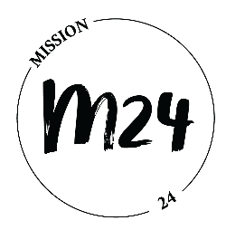

Application Form

- Personal Details
Surname:
Given Name:
Date of Birth:
Gender:
Marital Status:
Address:
Phone Number:
Email Address:
Occupation:
Education Level:

- Please answer the questions below as frankly as possible. They will help us understand you more in the selection process. There is no right or wrong answers to the questions.

- Mention three reasons why you want to join Mission 24.

- Have you joined any intercultural and/or intergenerational exchange programmes before?

- If yes, please state briefly what they are.

- Have you joined any mission trips before? If yes, please state briefly what they are.

- In the programme, each participant will be matched with a mentor for sharing and guidance. What do you most look forward to / expect in the mentorship?

- Do you have any experience with volunteering in church or other organisations?

- In what type of work/activities/ministry do you feel that you serve God the best, where God has gifted you?

- What do you think is your greatest weakness?

- Do you like being up in front of people, or do you prefer to work behind the scenes?

- In what ways do you think this programme will help you in your relationship with God, in serving His Kingdom?

- When you hear the word “mission”, what comes to your mind?

- In the programme, we will explore evangelism, diakonia, creation care, gender equality, human trafficking, gospel and culture, migration and inclusion, etc. Which of these topics do you find most interesting, or you are most passionate about, and why?

- There are two trips in this programme: one to Thailand (tentatively in July 2023) and one to Norway (tentatively in June 2024). How do you think these two trips will increase your knowledge about the topics mentioned in Q12?

- Most of the programme will be conducted digitally, including the online sessions on various topics and interaction with the mentors. Do you have any experience in online meetings? How do you think your participation in the programme will be affected when it’s done digitally, e.g. having your camera on, being active in the discussion, and sharing your thoughts digitally, etc?

